ITCS 1010 Programming Logic

Logic Plan 6 – Chapter 6 – 20 points

“Retail Price Calculator using a Method that Receives Arguments and Returns a Value”

Student Name ____________Steven Woodard______________

Given the following problem statements, perform the steps and answer the questions listed below, which are designed to help you analyze the problem and prepare a strategy for solving the problem. Submit this logic plan and C# Project into a folder, zip the folder, and submit in Blackboard for grading.

Problem statement: Create an application that lets the user enter an item’s wholesale cost and its markup percentage in input text boxes. When the user clicks the Calculate button, the application should have a METHOD named CalculateRetail that receives two inputs in text boxes, the wholesale cost and markup percentage as arguments, and returns the output retail price of the item in a text box. See textbook page 392, under Programming Problems, the Retail Price Calculator for guidance.

For example: Retail Price = (Wholesale Cost * Markup Percentage)

$10.00 = ($5.00 x 100%)
$7.50 = ($5.00 x 50%)
Student’s Note: /\
/
That’s not how that calculation works! 5 times 100 percent is 5 not 10.

Also, include an Exit button so the user can close the form and include your student name in the title bar of the form.

Use label controls, button controls, and program comments where applicable. Make sure the C# program is free of syntax and logic errors. Also, include user-friendly ToolTips on all button controls.
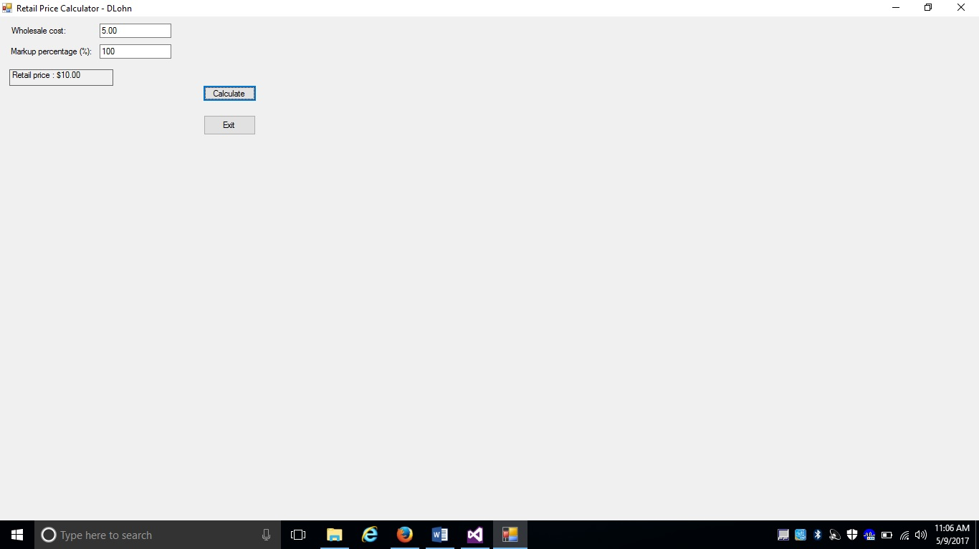
Create a file folder on your USB Port drive or hard drive at home, and call it “Logic Plan6 Your student name”. For example “Logic Plan6 DLohn”.

There is no VideoNote associated with this Lab.

Create the Logic Plan!

Before coding this program design the Program’s Logic: enter your answers in the IPO chart below. Write pseudocode and insert below. Draw a flowchart and insert below. (Hint: reference the logic plans in this Tutorial and Tutorial 6-4 for guidance.)

What must the user enter as INPUT?
INPUT
Whole Sale Cost
Markup Percentage
EXAMPLE: Whole sale price = $10.00
Markup percent =50%

How will the program calculate the retail price?
PROCESSING
Click event listener calls the get valid inputs method and the calculate retail price method with the whole sale cost and markup percentage arguments.
Then displays the returned value.
EXAMPLE
getValidUserData(output1, output2) (output1 = $10) (output2 = 50%)
retail price = calculateRetailPrice($10, 50%) ($15.00)
The get valid inputs method parses the user inputs, and checks if they are valid. And sends through errors if there are any.

EXAMPLE
Output1 = $10
Output2 = 50%
No errors…

The calculate retail price method returns the product of the whole sale cost times the sum of 100 percent and the markup percent

EXAMPLE
Return 10 * (1 + 100%/100) = $15.00

What OUTPUT will the program display?
OUTPUT
Retail Price
EXAMPLE $15.00

ENTER PSEUDOCODE HERE
//Calculate button event handler
//Declare variables to store user input
//Parse user input into variables, and check for errors
//Get retail price and display to user
//Get valid user input method
//assign variables to safe value for compiler to be happy
//Look for errors in the following code
//parse user input
//if user input is negative
//complain
//upon finding errors in the code
//set variables to safe state
//alert the user of an error
//Calculate retail price method
//calculate the price
//markupPercent = markUpPercent / 100
// return the result of calculating the retail value
// return wholeSale * (1 + markUpPercent)

//Exit button event handler
//close the program

DRAW OR COPY/PASTE FLOWCHART HERE
Please see next page for flowchart.

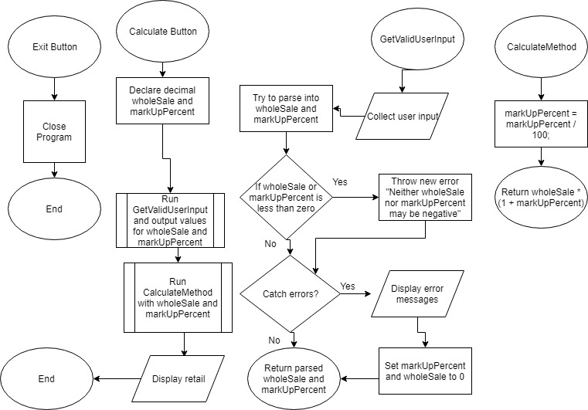

Save this project in your “Logic Plan 6 your student name” file folder and submit in this category for grading.

